New-Dis-**Eur-Germany-Vogelherd-Figurine-Mammoth-Ivory-Middle Paleolithic-**40,000 BP

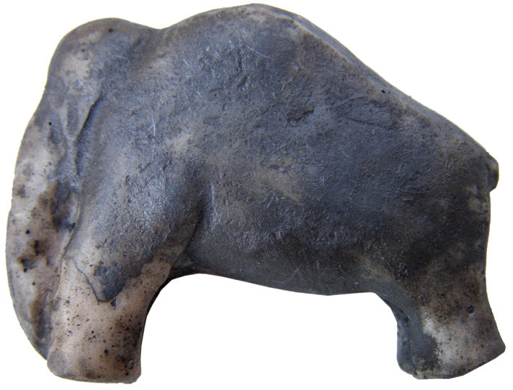

Fig. 1. **Germany-Vogelherd-Figurine-Mammoth-Ivory-Middle Paleolithic-**40,000 BP-29,000 BP

**Formal Label: Germany-Vogelherd-Figurine-Mammoth-Ivory-Middle Paleolithic-**40,000 BP-29,000 BP

**Display description:**

Vogelherdhöhle (“Bird Heart Cave”) was probably named for its location above the Lone River for attracting birds and its heart-like structure, since it has three chambers like a heart. It is among the most significant German Paleolithic sites. It is located on a sloping limestone ledge 20 m above the Lone River Valley over which it possessed a strategic view for hunters of Pleistocene game. **This ivory mammoth figurine dating to** 40,000 BP-29,000 BP **exhibits the shape of the mammoth and suggests that it is in the grips of inclement weather with its trunk snugged down in protection from the cold. In this respect it exhibits the intent of the artist to represent his reality, being less of a symbolic interpretation.**

**Accession Number:**

**LC Classification:** GN772.2.A8

**Date or Time Horizon:** 40,000 BP-29,000 BP

**Geographical Area: Vogelherd Site, Germany**

**Map, GPS Coordinates:** 48.561321, 10.189116

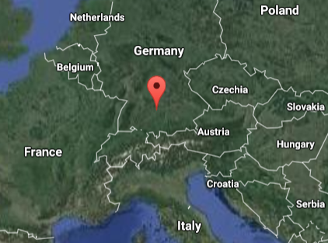

Fig. 2. Location of Vogelherdhöhle in the local landscape.

Fig. 3. Location of Vogelherdhöhle in Germany.

**Cultural Affiliation:** Aurignacian

**Medium:** mammoth ivory

**Dimensions:   
Weight:**

**Provenance: University of Tübingen.**

**Condition:** museum replica in resin**.**

**Discussion:**

On 23 May 1931 Hermann Mohn, a private researcher from Heidenheim, while probing the hills near Stetten bei Niederstotzingen for prehistoric remains, found flint artifacts in the rear of a badger den. He informed the prehistory department of the University of Tübingen of a potential Paleolithic cave, which he named ‘Mohnloch’ or Mohn’s hole.’ The Tübingen department, unimpressed, sent a junior researcher, Gustav Riek, to Stetten to inspect the site. The Y-shaped cave has three openings (S, SW and N) and covers 170 m2. Mohn and Riek squeezed through the 30 cm x 40 cm opening into the badger den and on the evening of the second day they found the Paleolithic evidence they were looking for: Mohn’s hunch was right, this was confirmed and the site was renamed “Vogelherdhöhle,” “Bird Heart Cave,” probably for the waters of the Lone River attracting birds and the cave’s three chambers like a heart. Then, in just three months, Riek had excavated the cave, with large back-fill mounds looming outside the three entrances still holding artifacts yet to be discovered but now without any context. In the intervening years these mounds have been thoroughly re-examined and many artifacts have been recovered.

There are four Middle Paleolithic strata and four Upper Paleolithic strata of Vogelherd Cave of which two of the latter, layers V and VI belong to the Aurignacian, which are the cultural strata for which Vogelherd is famous and in which the present artifact was found. (The Magdalenian is represented in two layers, the Gravettian is not present --as in almost all the cave sites of Lone River Valley--and the Neolithic affords the final evidence of human presence.)

Riek’s excavation yielded eleven figurines. The lower Aurignacian layer V supplied a total of seven, including a horse, a mammoth, the rear part and the front leg and neck area of a large mammoth figurine, a headless animal figurine, a lion figurine and an unidentified animal figurine with a reattached head from the excavations in 2012 (Conard et al., 2013). Four figurines from the upper layer IV include a lion, a steppe bison, a mammoth and an anthropomorph. Although the layer in which each figurine was excavated is known, Riek gave no indication of their exact positions and their contexts.

**References:**

Bosinski, G. 2013. “Les precurseurs de l'art aurignacien.” In P. Bodu, L. Chehmana, L Klaric, L. Mevel, S. Soriano and N. Teyssandier, N. (eds.), *Le Paleolithique superieur ancien de /'Europe du Nord-Ouest: Reflexions et syntheses a partir d'un projet collectif de* *récherche sur le centre et le sud du Bassin parisien: Actes du colloque de Sens (15-18 avril 2009)* Paris: Sociéte préhistorique française.

Conard, N. J., Zeidi, M. and Bega, J. 2013. “Die letzte Kampagne *der* Nachgrabungen am Vogelherd,” *Archaologische Ausgrabungen in Baden-Wurttemberg,* 2012: 84-88.

Delporte, H. 1990. *L'image des animaux dans l'art préhistorique,* Paris: Picard.

Delporte, H.. 1993. *L'image de la femme dans l'art préhistorique. Nouvelle edition augmentée,* Paris, Picard.

Hahn, J. 1970. “Die Stellung der mannlichen Elfenbeinstatuette aus dem Höhlenstein-Stadel in der jungpaläolithischen Kunst,” *Germania,* 48: 1-12.

Hahn, J., Muller-Beck, H. and Taute, W. 1985. *Eiszeithöhlen im Lonetal.* Stuttgart: Konrad Theiss Verlag.

Niven, Laura. 2006. The Palaeolithic Occupation of Vogelherd Cave: Implications for the Subsistence Behavior of Late Neanderthals and Early Modern Humans. Tübingen: Kerns.

Riek, Gustav. 1934. *Die Eiszeitjägerstation am Vogelherd im Lonetal*, Bd. I: Die Kulturen. Leipzig: Kabitzsch.

Riek, Gustav. 1935. *Kulturbilder aus der Altsteinzeit Württembergs*. Tübingen: Franz F. Heine.